Inspired by: http://www.ardendertat.com/2011/05/30/how-to-implement-a-search-engine-part-1-create-index/

The current pipeline for Page ranking algorithm is which I build is as follows:

=> Match word frequency of Query with the corpus
=> Find Pages having highest rank
=> Sequence Length Matching
=> Find Pages having highest rank
=> Train Count Vectorizer and Fit only Highest Rank Pages
=> Cosine Similarity between Query and Vectorized Sentence

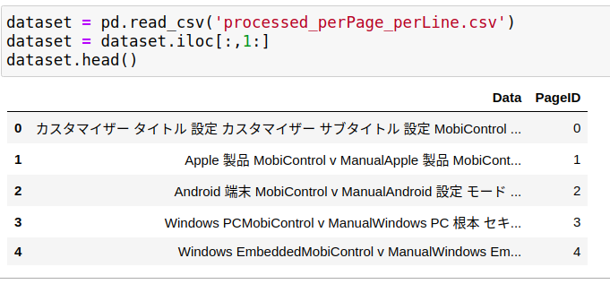
Generate Words → Ids

[(3304, 'ｷｬﾝｾﾙ'),
(5097, '黒鉛'),
(5525, '黒色'),
(1911, '黒い'),
(4576, '黒'),
(210, '黄色い'),
(5171, '黄色'),
(4147, '鳴る'),
(6345, '鳴り'),
(1885, '鳴らす'),
(1742, '鳴らし'),
(5480, '高額'),
(96, '高速'),
(326, '高度'),
(6070, '高める'),

Lines are converted to vectors
([4744, 6098, 3139, 4744, 6549, 3139,  5719, 3139], 0) | ([word1, word2, word3, …………,], PageID)

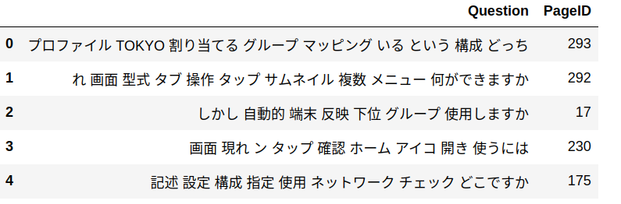

Similarly Query is converted to query_vector
[5884, 2758, 6427, 3067, 1364, 2589, 5152, 6049]

def return_match_length(a, b):  ….  return int(matched_length)  query = [1,2,3,4,5,20]  corpus_vector_each_line = [2,3,6,7,8,9,19,20] | It returns 3 because matching with 2,3,20 it does not consider the position of the list items

Sorting rank

[(8, 324), (8, 293), (8, 262), (8, 177), (8, 148), (8, 105), (8, 53), (7, 437), (7, 367), (7, 229), (7, 17), (6, 387), (6, 362), (6, 341), (6, 257), (6, 223), (6, 202), (6, 87), (6, 83), (6, 28), (5, 444), (5, 425), (5, 424), (5, 413), (5, 411), (5, 396), (5, 372), (5, 368), (5, 271), (5, 258), (5, 252), (5, 239), (5, 232), (5, 227), (5, 187), (5, 156), (5, 145), (5, 134), (5, 130), (5, 79), (5, 69), (5, 61), (5, 60), (5, 40), (5, 31), (5, 29) | [(Number of ID match, PageID), ]  This reflects which are the top matching Pages in the corpus with the Query statement.

[[8, 324],  [8, 293],  [8, 262],  [8, 177],  [8, 148],  [8, 105],  [8, 53],  [7, 437],  [7, 367],  [7, 229],  [7, 17]] | Collecting only Top most and 2nd top most matching Pages. Discard the rest pages -  Here I might loose best candidate. But that candidate does not have high matching words with the Query.

Now def sequence_matcher(sequence1, sequence2):

return matching_result_collection
[[4.5, 324],  [4.5, 293],  [4.5, 262],  [4.5, 177],  [4.5, 148],  [3.0, 105],  [3.0, 53],  [1.5, 437],  [1.5, 17],  [1.0, 229],  [0.5, 367]] | import difflib  matches = difflib.SequenceMatcher(  None, string1, string2).get_matching_blocks()  for match in matches:  print string1[match.a:match.a + match.size]  OUTPUT ab cd
Calling Count Vectorizer and fitting with whole corpus

vec, text_collections, ids_list = filtered_vector(sequence_wise_rank, vectorizer, dataset)

Transform each corpus pages with count vectorizer and then measure cosine similarity between Query and selected corpus pages

X = vec.transform([str(query)])

rank=[]
for contents in text_collections:
Y = vec.transform([contents])
rank.append(cosine_similarity(X, Y))

[(array([0.45811281]), 262),
(array([0.45548391]), 105),
(array([0.44427103]), 53)]

Next I would like to make a rank based on bert vectorizer and number of tokens matches with the page elements. But struggling here because the vector size of query vector and Trained vector does not matching. Dimension problem. Need more research here.

